Chapter 19, Solution 60.

Comparing this with Fig. 19.5,

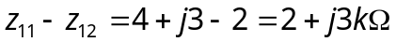

z₂₂ – z₁₂ = 5 – j – 2 = 3 – j kΩ

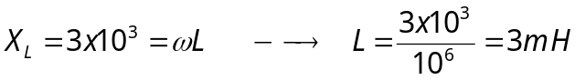

X_{C} = 1x10³ = 1/(ωC) or C = 1/(10³x10⁶) = 1 nF

Hence, the resulting T network is shown below.

2 kΩ 3 mH 3 kΩ 1 nF

2 kΩ

